**Workshop – ETL – Chinook**

Creating the data warehouse structure for Chinook in four databases

MySQL database

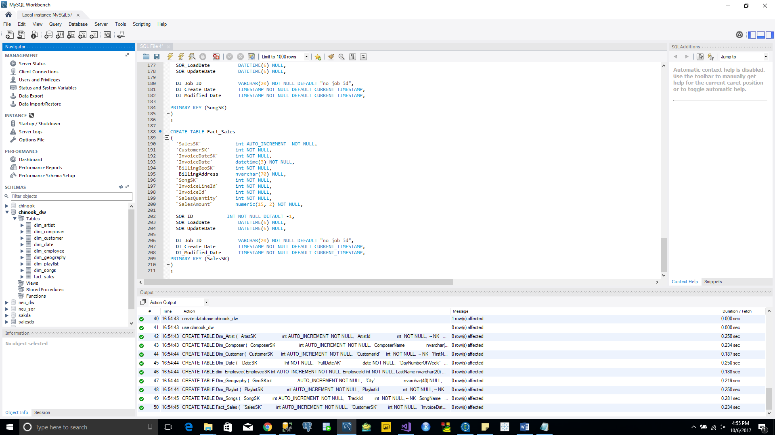

SQL server database:

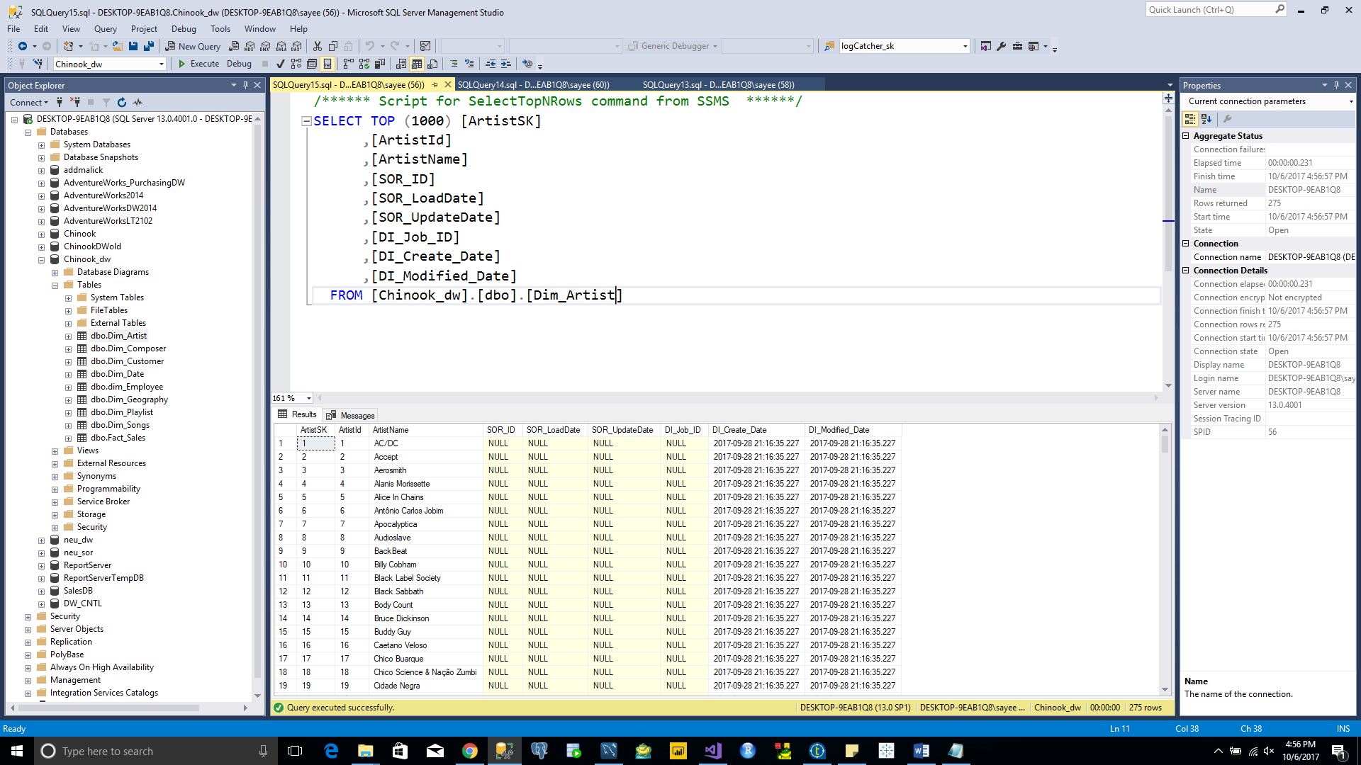

Oracle database:

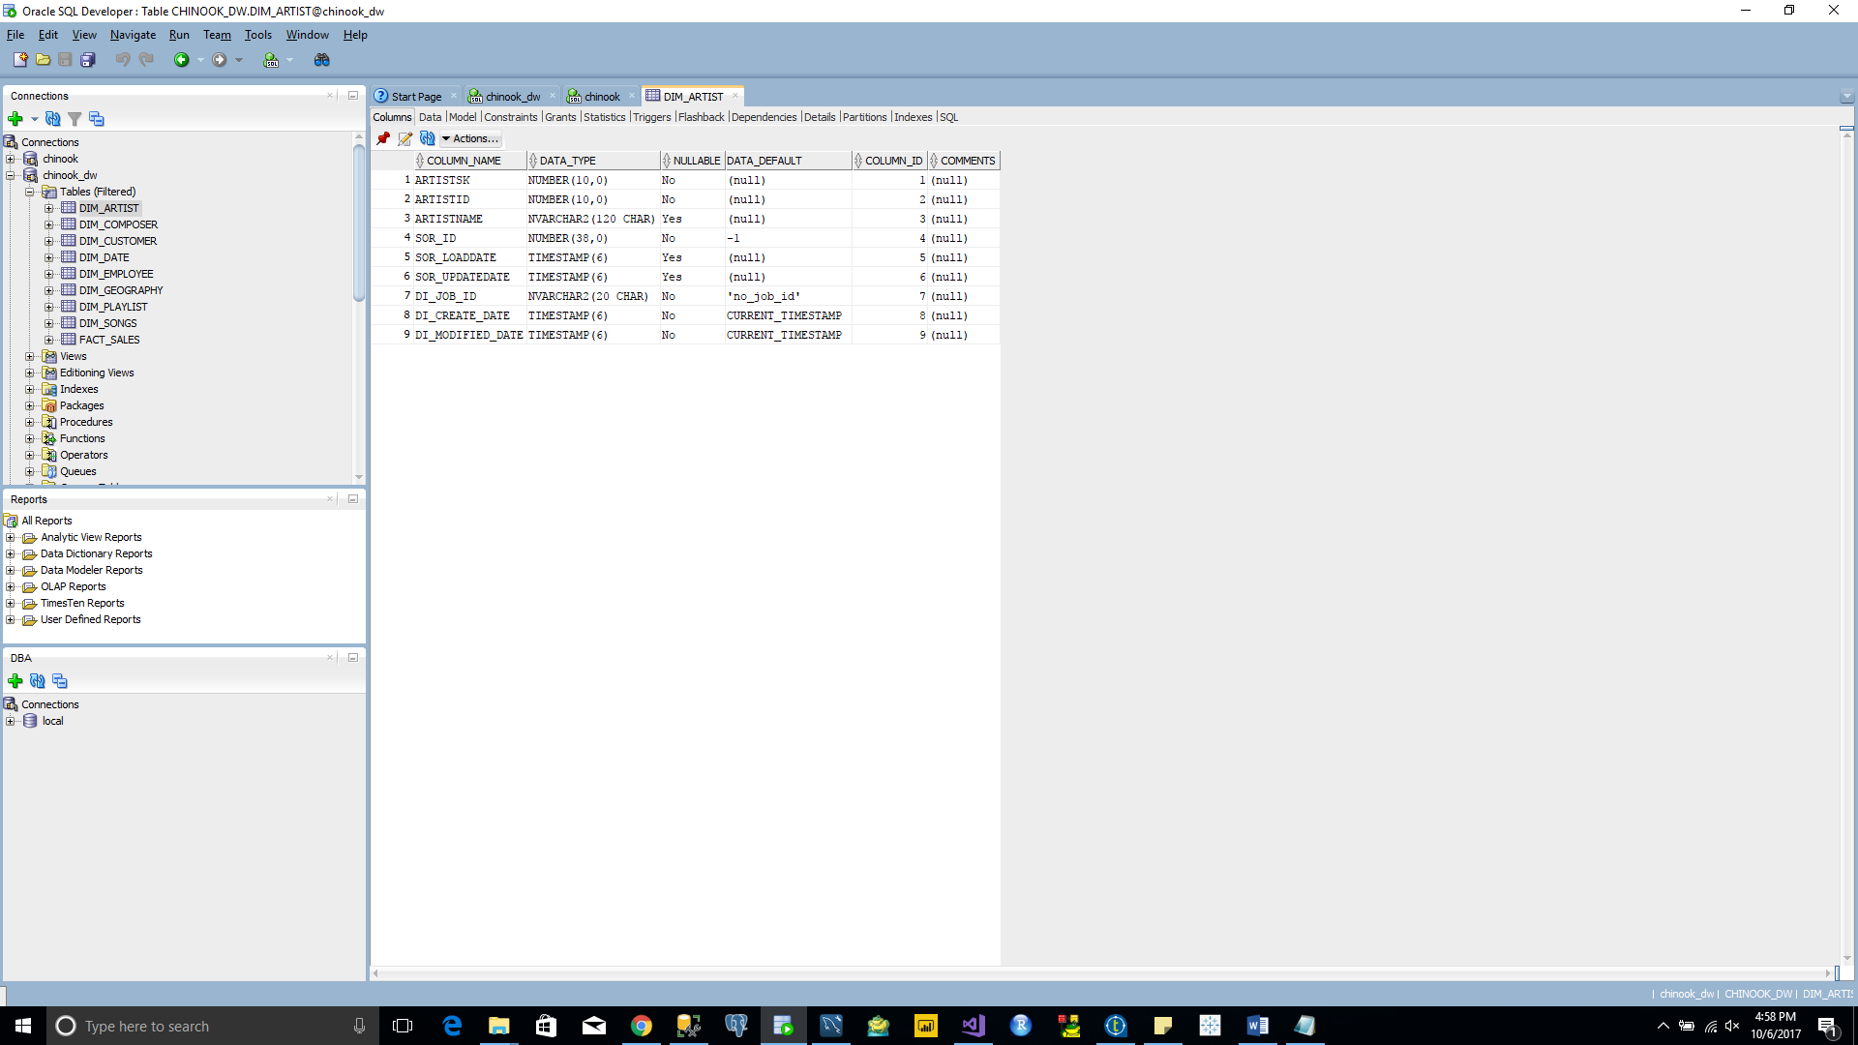

PostgreSQL database:

